

**Charles Dickens School**

***Parent Handbook***

*2024-2025*

**Vision**

Charles Dickens School builds the academic, social, and emotional foundations that students will need to empower a community of learners in thinking, innovating, creating, and preparing students for success in high school, college, and beyond.

**Motto**

Every single minute matters, with every single student, every single day.

**Things You Must Do as a Charles Dickens Parent**

* Completely fill out the Emergency Card and inform us of any health problems and/or other concerns. If your child needs to use an inhaler or take prescribed medication during school hours, please provide the school with the doctor’s written instructions and the original medicine container.
* **Notify the school regarding absence, tardiness, or changes in telephone number or address. You may call 216-838-4200.**
* **ENSURE PROPER CARE OF YOUR SCHOLARS LAPTOP.**
* Help with homework and provide a quiet or an appropriate place for your child(ren) to study.
* Check papers that are brought home.
* Send your child(ren) **Dressed in Full Dress Code! (Leggings must have a long shirt to cover exposed areas, no biker shorts, tank tops, open toed shoes or Crocs i.e. review attached dress code)**
* NO flip-flops, crocs, sandals of any kind, high-heeled tennis shoes, or high-heeled boots.
* Send your healthy child(ren) to school each day.
* Send the child(ren) with the proper supplies for instruction and learning. **Especially their laptop.**
* See that all letters sent home are signed, dated and returned.
* Send the child(ren) to school on time.
* **Do not** send gum, candy, games, toys, headsets, tablets, or handheld games.
* Attend Parent-Teacher Conferences, Report Card Pick-Up Nights, and other school events that support your child’s education and fun.
* Discuss any concerns you have about your child’s behavior and academic performance with the Teacher or the Principal.

**Send Your Child to School Every Day!**

If your child must be absent, call the school in the morning (216-838-4200). Send a note to explain the absence when the child returns to school. Please make both contacts whenever your child is absent.

**District-wide CMSD K-8 Student Dress Code Policy**

Charles Dickens has an ongoing commitment to academic excellence. As part of that commitment to excellence, we will strictly enforce the **CMSD Dress Code** **Policy** (attached to this letter). All students are expected to comply. We believe there is a direct relationship between being well-groomed and properly dressed and having productive work habits for school. The clothing students wear can have a bearing on their external conduct as well as internal attitude. We believe that helping young people “dress for success” at an early age will have long-term benefits. Your support and cooperation is needed and appreciated.

**METAL DETECTORS**

Metal detectors will be used as students, parents and guests enter the school each day. This will require patience as we have a very large student population. ALL will be required to pass through the metal detector. Students and parents will be asked to place all belongings on the table as they will be searched and then one proceeds through the detector. If the detector sounds, the individual will then be searched so we can guarantee your child’s safety at school. Your cooperation and understanding are greatly appreciated.

**ATTENDANCE**

In order to achieve our goal of 95% attendance, daily attendance is a must. Regular attendance is vital for student success. Research shows that most students who fail or do poorly in school do so due to poor attendance. Parents are expected to call school (216-838-4200) in the morning if their child will be absent. Upon the return of the child to school, a note must be sent explaining the reason for absence. STATE LAW REQUIRES A NOTE. The note must have the student’s name, date, reason for absence and the signature of the parent or guardian. Excused absences are for:

* COVID-19 Positive (Please Call the Office)
* Illness
* Religious Holiday
* Death in the Family
* Unusual Circumstances (must be explained in writing and approved by the Principal or Assistant Principal)

*For those students with chronic attendance problems, a CMSD Attendance Liaison has been assigned to our school. The attendance liaison will send letters, make phone calls, conduct home visits, work with CMSD Truancy office, and make referrals to County Social Services as needed. Please work with us so that poor attendance does not become an issue.

**HALF-DAY ABSENCES**

Instruction begins at 9:35 am and ends at 4:05 pm. Students who miss more than 1 ½ hour in the morning or 1 ½ hour in the afternoon will be marked for a ½ day absence. Any student arriving after 11:00 am or leaving before 1:30 pm will be marked ½ day absence. Student absences will accrue in minutes and after so many minutes that turn to hours, students will be reported for truancy. **Students will not be released after 3:30pm without prior notice by phone call or note.**

**CELL PHONES TOYS AND ELECTRONIC DEVICES:**

The District is committed to providing a safe, positive and productive learning environment for its students. The District recognizes that, depending on how they are used, cellular phones and other electronic devices can be either a valuable learning tool or a source of disruption in the learning environment. In order to maintain a secure and orderly learning environment, student use and possession of cellular phones and other electronic devices shall conform to the appropriate use standards of this policy.

Students may not possess cellular phones and other electronic devices on school property and school-sponsored transportation. Dives should be powered of and placed in a Yondr pouch immediately upon entering the school building. A cell phone or electronic device is limited to appropriate uses as defined by this policy. Any other use of cellular phones and other electronic devices on school property, while on school-sponsored transportation, or while engaging in school-sponsored activities is prohibited. When not using their cell phone or other electronic device for an authorized, appropriate purpose, students are responsible for keeping their cell phones and electronic devices powered completely off (not simply in a “vibrate,” “silent,” or “airplane” mode) and stored securely in their assigned Yondr pouch.

**Authorized Uses of Cell Phones and Electronic Devices**

The District has determined that the following uses of cell phones or electronic devices by student may be appropriate:

a) Communications with a student’s immediate family members in the event of a Districtwide or schoolwide emergency as defined by the building administrator.

b) Communications with a student’s immediate family members authorized by a building staff member and that take place under the supervision of the authorizing staff member.

**Unauthorized Uses of Cell Phones and Electronic Devices**

Although students are empowered to use cell phones and other electronic devices in specific, appropriate ways as described above, students are never authorized to use a cell phone or electronic device for the following purposes:

a) In violation of any other section of the Student Rights and Responsibilities, including, but not limited to the District’s prohibitions against cheating, posting or distributing materials that disrupt the educational process, intimidation, threatening to injure or harm others, use of profane or abusive language, hazing, bullying, disrupting the school environment, and failure to adhere to school culture or directives of school personnel.

b) In any manner that creates a disruption or impacts the safe operation of school transportation.

c) To commit a crime, under federal or state law.

d) To violate another person’s reasonable expectation of privacy by using cell phones or other electronic devices in locker rooms, restrooms, or any other changing areas.

e ) To take photographs, audio recordings, or video recordings of other individuals, including other students, teachers, administrators, staff members, or members of the community without the explicit authorization of all individuals being photographed or recorded.

Cellphones and other electronic devices used by any student while on CMSD school property, should not occur without staff supervision. Violations of this policy will result in confiscation of the electronic device by a building administrator.

**1st Offense** = Electronic device will be confiscated by teacher or administrator and stored per our cell phone policy

**2nd Offense** = Electronic device will be confiscated by teacher or administrator and stored and a parent will be contacted in order for the phone to be released.

**3rd Offense** = Electronic device will be confiscated by teacher or administrator and stored and a parent contacted pending suspension and/or expulsion or other discipline as a repeated offender.

**Repeated or chronic violations of the cell phone and electronic device acceptable use policy constitute a Level 2Q offense. Refusal to surrender a cellular phone or electronic device to a teacher or administrator attempting to confiscate it pursuant to this policy constitutes a Level 2I offense.**

*Repeated violators will be subject to further disciplinary action including but not limited to suspension and/or expulsion according to the CMSD Student Code of Conduct.

**CHANGE OF ADDRESS OR TELEPHONE #**

The school must maintain accurate addresses and telephone numbers in case of an emergency. If your address or phone number changes at **any time** throughout the year, please contact the school office immediately so we may update our records.

**NON-SMOKING BUILDING/NO EXCEPTIONS**

Smoking is prohibited on all Cleveland Metropolitan School District property. This includes the school yard and parking lot areas. Please comply with this policy.

**VISITOR POLICY**

If parents would like to meet with teachers or administrators, please call the office to make an appointment.

**CONFERENCES**

Parent-Teacher conferences are an essential component of a successful education. They provide the necessary link between home and school. Conferences are to be scheduled either by calling the school or by sending a note to your child’s teacher. Parent-Teacher conferences must be arranged in advance and they must be scheduled for a time outside of instructional periods.

**Administrators are not available for conferences during student arrival (9:00 – 9:45), dismissal (3:30 – 4:00) or during lunch periods (12:00 – 2:20 pm). An administrator meeting request must be made with Ms. Lewis in the main office.**

**EARLY DISMISSAL**

# Please keep in mind, students attend school for only 6 ½ hours each day. We at Charles Dickens School value education and the instruction that takes place during the school day and will not permit students to leave before 3:50 p.m. except for extreme emergency. Parents who repeatedly pick their child up early from school may be reported to the Department of Children and Family Services. According to the Ohio Department of Education traditional school districts must comply with minimum hours of instruction instead of a minimum number of school days each year. Just think …every minute you take your child out of school early or get them to school late is counted against their attendance and they are also missing valuable educational time.

**TELEPHONE USE**

Telephones are for school business only. They are not to be used by students except in an extreme emergency. Students may not use phones to call home for homework, lunch, etc. We do realize that emergencies may arise which require you to call and speak to your child. During the academic day, students will not be called to receive a phone call unless it is for an extreme emergency. We are sure you understand our desire to limit the number of distractions throughout the academic day.

**HOMEWORK**

Students at every grade level will be assigned homework at least 4 nights a week. Please monitor completion of homework daily.

**NURSE**

Charles Dickens School has a nurse every day. If you know that your child is ill, please keep him/her at home, and notify the school by telephone of the illness. Germs spread rapidly in a school setting, and we would like to keep our students as healthy as possible. If a child gets sick during the school day, it is important that your contact information is up to date so that the nurse can reach you.

**BOOKS AND SUPPLIES**

All students are responsible for caring for their **laptop** assigned class books, library books, and assignment notebooks. Payment will be expected for damage and/or lost laptops and books. It is expected that all students arrive at school with necessary supplies prepared to work.

**POSITIVE BEHAVIOR INTERVENTION AND SUPPORTS (PBIS)**

At Charles Dickens Elementary we believe in supporting scholars’ behavioral, academic, social, emotional, and mental health. We do this through our building wide positive behavior intervention and support system that we have developed called P.A.W.S. Our building PBIS system focuses on creating common language and expectations for scholars and staff. We will work with our scholars to provide clear instruction and recognition for their demonstration of the skills taught in this program. We believe that by implementation of the P.A.W.S. program with fidelity that we will ensure our scholars have improved social emotional competence, greater academic success, and foster a positive school atmosphere.

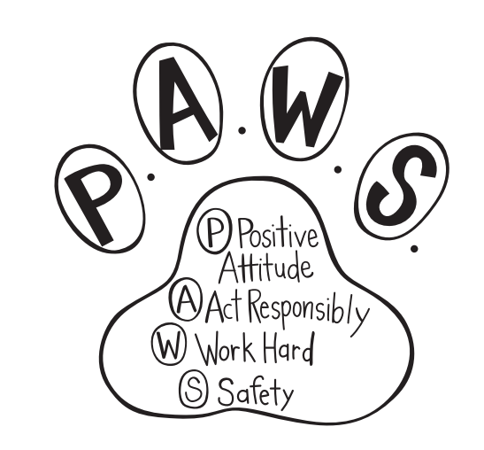

**P.A.W.S. Traits**

|  |  |  |  |
| --- | --- | --- | --- |
| Positive Attitude | Act Responsibly | Work Hard | Safety |
| * Appreciation of Beauty and Excellence * Gratitude * Hope * Humor * Sense of meaning | * Bravery * Humility * Teamwork * Fairness * Leadership | * Perseverance * Honesty * Zest * Prudence * Creativity * Curiosity * Judgement * Love of Learning * Perspective | * Love * Social intelligence * Kindness * Self-control * Forgiveness * Humility |

**Say Yes Cleveland**

Say Yes Cleveland is a local organization that provides two big things for Cleveland students:

* Support services for students in CMSD and partner charter schools from PreK through graduation; and
* Tuition scholarships to college or career training for all eligible scholars after high school graduation.

***Support Services***Say Yes Cleveland support services are intended to help students overcome barriers and stay on-track for success. There’s a Say Yes Cleveland Family Support Specialist in every CMSD school building to connect students and their families with the help they need when you need it.

FREE Say Yes Cleveland Support Services available to students and families include:

|  |  |
| --- | --- |
| Legal Assistance for every student and family   * Expungement, bankruptcy, eviction, adoption, custody/visitation, and more   Academic tutoring   * Virtual, In-Home, Community-Based Tutoring   Food assistance   * Emergency and on-going food access   Home and Housing   * Utilities support, tech access, referral-based housing assistance, and emergency placement | Behavioral and mental health services   * ADHD, trauma care, special needs support, and more   Medical, vision, and dental services   * Exams, vaccines, illness treatment, free glasses/repairs   Clothing and Everyday Needs   * Coats, shoes, hygiene products, and more |

Each fall, we ask all Parents/Guardians, Teachers, and Students (5h grade and above) to complete Say Yes Cleveland's surveys, which are critical tools used to help our Family Support Specialists understand the needs of students and families, in order to provide connections to the best resources to support mental and physical health, social well-being, and academic success and more. The surveys also let the FSS identify urgent issues (known as Red Flags) impacting students or families that need immediate intervention.

***Scholarships***

For at least the next 25 years, Say Yes Cleveland will provide tuition scholarships to college or career training programs for all eligible CMSD graduates. Say Yes Cleveland scholarships have already helped nearly 3,000 CMSD graduates pursue postsecondary education in just its first four years.

Say Yes scholarships can be used at all public Ohio universities, community colleges, and Pell-eligible career training programs, as well as over 100 private colleges and universities throughout Ohio and across the nation.

To be eligible for scholarships, students must:

* Enroll in a CMSD (or partner charter) high school from 9th grade through graduation; and
* Live within CMSD boundaries or City of Cleveland from 9th grade through graduation.

Say Yes tuition scholarships do not mean ‘free college.’ Our scholarships only apply to tuition (the cost of classes). If the student decides to live on campus (in a dorm), the cost of food and housing (called ‘room & board’) can be several thousand dollars every year and Say Yes scholarships do not pay those costs.

For families with an annual income of $75,000 or below, the Say Yes scholarship will pay 100% of the tuition remaining after federal and state grants. For families with an annual income above $75,000, the Say Yes scholarship will cover up to $5,000 in remaining tuition each year after federal and state grants.

Parents/caregivers MUST fill out a Free Application for Federal Student Aid (FAFSA.gov) for a student to receive a Say Yes scholarship. The FAFSA tells how much federal and state aid the student will receive, which determines the amount of their Say Yes scholarship.

Scholarships are funded from more than $98 million contributed (to date) by private philanthropy, foundations, corporations and individuals in Ohio.

For more information about Say Yes Cleveland support services and scholarships, contact your school’s Say Yes Family Support Specialist, or visit [www.SayYesCleveland.org](http://www.SayYesCleveland.org).

**CMSD Dress Code**

**(Per Students’ Rights and Responsibilities)**

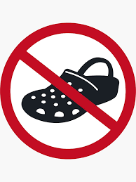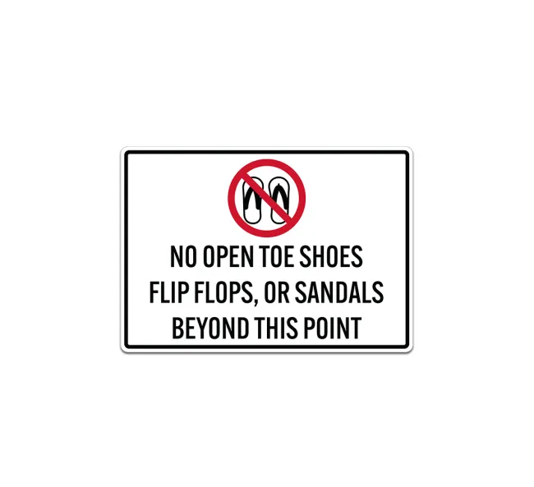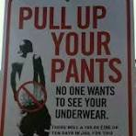

The responsibility for the dress and appearance of a student rests primarily with the student and their parents or guardians. In the interest of maintaining a safe and healthy learning environment, the district believes in the following basic principles:

* All students are encouraged to dress in a manner that is appropriate, comfortable, and conducive to an active academic school day.
* Students should be able to wear clothing without fear of or actual unnecessary discipline or body shaming.
* The student dress code should serve to support all students to develop a body-positive self-image.
* The district standard dress and appearance policy is gender neutral and applies to all students equally regardless of gender on school campuses and at school-sponsored functions and will be enforced consistently and fairly by all members of the school staff.

Examples of inappropriate clothing include:

* clothing where the buttocks or torso is exposed
* clothing that is see-through (clothing must be opaque)
* Bed clothing, pajama pants, bonnets, caps, hats
* clothing or accessories that show profanity, obscene words or pictures, sexually suggestive statements, violence, or incitement to violence
* clothing representing gang-related activities
* clothing where the entire thigh is exposed
* bathing suits or cut-offs
* the wearing and carrying of tobacco promotional items, or items promoting controlled substances (drugs) and/or alcohol
* clothing where undergarments are exposed clothing that has text or visual images that is libelous, bullying, constitutes harassment or discrimination
* backless or open toe footwear (footwear must be worn at school and all functions)

Parents are models for behavior and expectations. Please consider how certain attire/ clothing items may be distracting or embarrassing for students when parents wear those items into the school setting to conduct business.

Site leadership (UCC subcommittee plus one parent) with a survey from parents, may establish a site-specific dress code addendum in the following circumstances:

* Times when students are engaged in extracurricular or other special school activities and where the standard dress and appearance policy would not be appropriate for the activity.
* Times when students are engaged in specific courses where modification is needed to ensure the safety of the students engaged in the class. Examples include lab sciences, physical education, CTE classes or other classes that contain potential hazards.
* Schools may set their own site-specific addendum relating to hats, caps and other head coverings. There shall be no restriction on student head coverings worn for bona fide religious purposes.
* Each school site, in accordance with the District Dress Code Review Process (as directed by Dress Code Committee, which meets once a semester) may develop additional guidelines stricter than the district’s minimum standard dress and appearance policy; however, these site-specific dress code addendums may not contradict the district’s dress and appearance policy outlined in this document. Schools are responsible for following the identified district policies on notification of students and parents for their site-specific addendums.

Dress and Appearance Code violations will have consequences that are applied consistently and equitably. Except under exigent circumstances, suspension or expulsion will not be used as a consequence for the violation of a dress code.

Site Staff shall provide students opportunity to remedy the violation. Opportunities to remediate may include, but are not limited to, parental contact, offer of exchange of clothing, referral to the Student Support Team (SST), or to the Say Yes Coordinator. Any discipline that shall arise out of dress code violations shall have minimal loss of instructional time as its goal.

**First Violation:** Administrator, or designee (not a CTU member), can make a parent/guardian call. Student will be offered the opportunity to remedy the situation, which could include an exchange of clothing, if available, turning a shirt inside out, or other potential remedy. Verbal warning given.

**Second Violation:** Administrator, or designee (not a CTU member), will make a parent/guardian call. Student will be offered the opportunity to remedy the situation, which could include an exchange of clothing, if available, turning a shirt inside out, or other potential remedy. Written warning given.

Subsequent Violation(s): Administrator, or designee (not a CTU member), will make a parent/ guardian call. Student will be offered the opportunity to remedy the situation, which could include an exchange of clothing, if available, turning a shirt inside out, or other potential remedy. Parent conference will be scheduled. Detention can be considered as a consequence.

If a parent/guardian or student disagrees with the site administrator’s decision on a standard violation, the parent/guardian or student shall attempt to resolve the problem by requesting a personal conference with the site administrator. If the problem cannot be resolved informally to the parent/guardian’s or student’s satisfaction, the site administrator’s decision may be appealed to the CEO’s designee, whose decision shall be final.

**Dangerous or Disruptive Violations:** Dress or appearance violations that cause actual disruption of the educational environment, result in actual violation of law or other school rules, including hate-crime laws, or cause actual injury may result, at the discretion of the district Administration, in more serious disciplinary action, up to and including expulsion without regard to the policy set forth above for standard violations. The process for appeal of these dangerous or disruptive violations shall be consistent with standard district disciplinary procedure.

**Exception to Regulations**

Generally, these neutral dress rules will be applied to all students without regard to personal circumstances. However, religious beliefs, medical requirements or other reasons may be grounds for an exception to a specific portion of the district Standard Dress & Appearance policy with specific advance approval from the district. A petition for an exemption from enforcement of a specified portion of district Standard Dress & Appearance policy may be submitted to the principal. Under no circumstances will the principal allow an exception for dress that displays gang symbols, uses profanity, displays products or slogans that promote tobacco, alcohol, drugs or sex, materially interferes with schoolwork, materially disrupts the school environment, substantially disrupts the school environment or creates a risk of safety.

**Gang-Related Apparel**

Gang-related apparel is not acceptable. If individual schools that have a dress code prohibiting gang-related apparel at school or school activities, the principal, staff and parents/guardians participating in the development of the school safety plan shall define “gang-related apparel” and shall limit this definition to apparel that reasonably could be determined to threaten the health and safety of the school environment if it were worn or displayed on a school campus. Principals will collaborate with Law Enforcement Agencies to update changes in gang-related apparel at the beginning of each semester or as often as needed. Because gang-related symbols are constantly changing, definitions of gang-related apparel shall be reviewed at least once each semester and updated whenever related information is received.

**Our Commitment**

We, at Charles Dickens, have pledged ourselves to the delivery of the highest quality educational services for your child. We are dedicated and committed to educating students to meet their highest potential. Every child has greatness within himself or herself, and we do our best to bring that greatness to the surface. With the support of a nurturing school family, caring parents and an uplifting community, we look forward to celebrating your child’s successes throughout the school year.

This Handbook is designed to help you understand the policies and the daily operation of our school. We believe that good communication and understanding between home and school promote the best possible care for your children. We encourage you to take the time to read the information in this handbook and in the supplemental materials and newsletters that you receive periodically.

If you find that you have questions or concerns not covered in the handbook, please feel free to discuss them with your child’s teacher or with us. We consider you to be an important part of the school and we value your suggestions and comments as well as your support. Our door is always open, and it is with open arms that we welcome visitors and volunteers. Here’s to another successful year!

Sincerely,

Malaika Phillips, Principal Ulysses Stokes, Assistant Principal

Charles Dickens School